Happy February, Foothills Mountaineers!

Are you looking forward to a fun and fabulous February? Our intrepid Foothills trip leaders are offering plenty of exciting activities and courses throughout the month. Check out all the upcoming activities and start planning your next outdoor adventure!

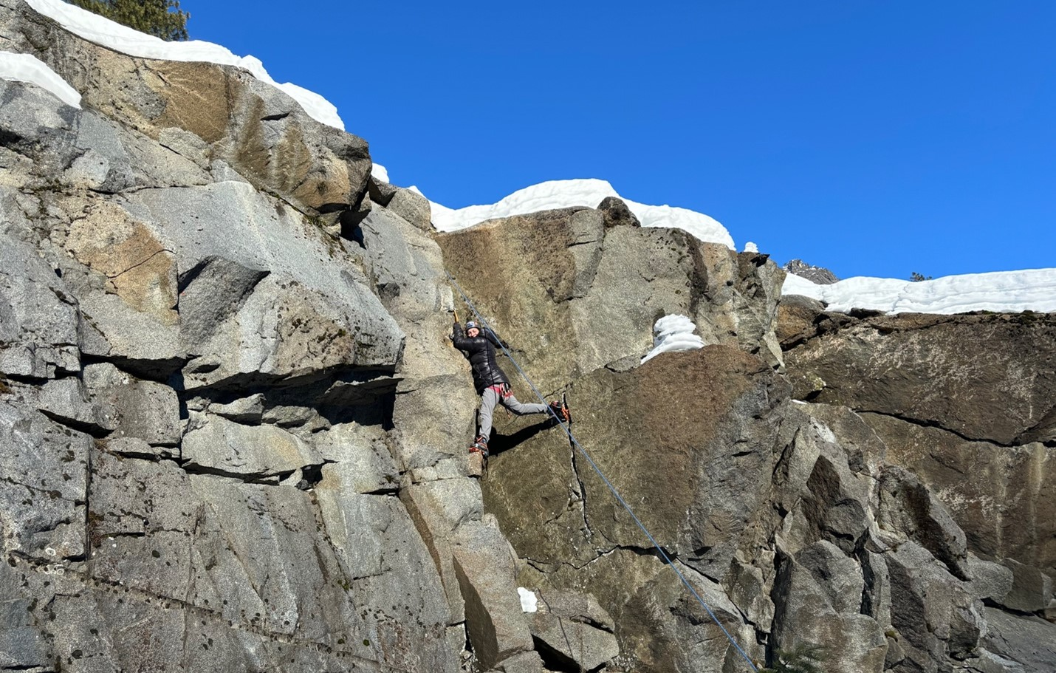

A Mountaineer dry tooling in Icicle Canyon. Photo by Sam Benefiel.

Events & Activities

Foothills Branch Council Meeting | Mar 4
Join us to meet the Foothills Branch Council and learn about upcoming branch activities and plans.
Return of the North Cascades Grizzly Bears | Mar 13
Join the Foothills Backpacking Committee for an evening with Conservation Northwest to learn from Washington & U.S. Fish and Wildlife Service staff about the return of the grizzly bear to the North Cascades.
Upcoming Stewardship Activities
The Foothills Conservation Committee is pleased to announce the postings of their spring and summer 2025 stewardship events with our partners Mountains to Sound Greenway. Join us at Oxbow Lake Loop on Mar 8, Mount Si Main Trail on Apr 12, and Middle Fork Snoqualmie River on Jun 7 & 14.
The Mountaineers Annual Gala | Apr 26
Tickets are on sale for the 2025 Annual Gala, Adventure with Purpose! We're excited to welcome professional climber Sasha DiGiulian as our Keynote Speaker, and world-renowned photographer Art Wolfe will be presented with our Adventure with Purpose Award. The Gala is our biggest fundraiser of the year - all proceeds from tickets, live and online auctions, and Raise the Paddle donations benefit the year-round programs and mission of The Mountaineers.

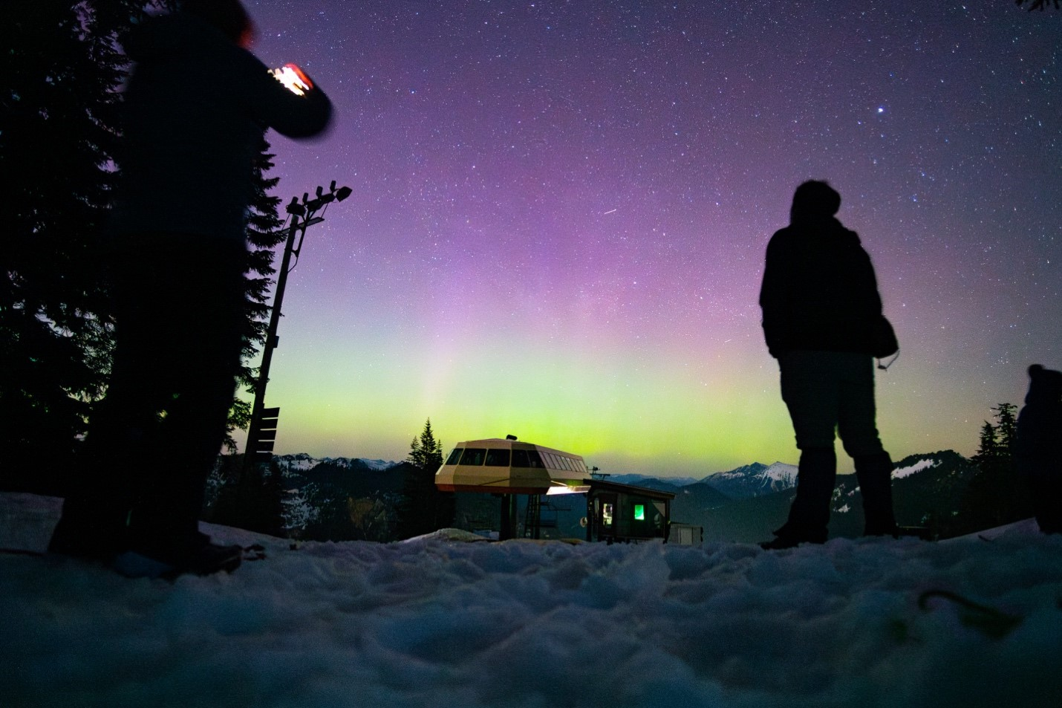

An aurora illuminates the evening at Stevens Pass Ski Area. Photo by Chris Fairfax.

Courses, Clinics, & Seminars

Leadership Development Series | Ongoing
Join us for our next Leadership Development Series seminars that provide high-quality, continuing education opportunities for our current and aspiring volunteers.
- Feb 13 - The 4 P's: Supporting Mountaineers Who Menstruate, Pee, and Poop in the Backcountry with Anastasia Allison
- Feb 19 - Dealing With Challenging Participant Behaviors: Coaching Individuals Toward Positive Change with Dr. Laura Thompson
- Feb 25 - Finding Comfort and Confidence Across the Entire Menstrual Cycle While in the Backcountry with Angie Marie
- Mar 4 - Workshopping Leadership Skills and Team Dynamics to Best Support Your Participants with Lyra Pierotti
- Mar 5 - What’s Next? Moving Beyond DEI 101 with Bam Mendiola
Shoulder-Season Backpacking | Starts Feb 20
In this course, learn how to envision, plan, and lead rewarding backpacking trips during the spring and fall months. Field trips will give you a taste of early season backpacking and its many rewards.
Backpacking Building Blocks (B3) | Starts Mar 6
Jump-start your backpacking dreams with the Backpacking Building Blocks (B3) course! This comprehensive course provides skills lectures, gear demonstrations, and extraordinary backpack trips in the PNW backcountry with the support and community of mentor groups led by experienced Mountaineers backpack leaders.
Conditioning for Hiking & Backpacking | Mar 26
In this clinic, learn exercises to strengthen major muscles used during hikes and backpacks, and build a personal conditioning and strengthening plan for the upcoming season. Gain mobility, stability, and strength to travel the trails with ease and help prevent unnecessary falls and injuries.
Staying Found: On-Trail Navigation | Starts Apr 22
In this course, learn and practice key skills to maintain an ongoing awareness of where you are and how to find yourself if you get lost on complicated trail systems.
Backpacking With Kids | Starts Apr 22
This course is for parents with some backpacking experience who want to take their children (little ones to teenagers) backpacking to explore the Pacific Northwest. Learn more about trip planning, trail tips, kid-oriented food, gear, and safety recommendations, and meet other interested families.

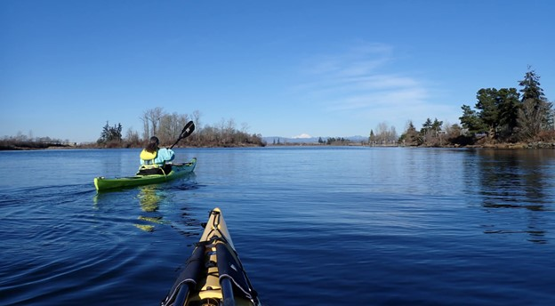

Photo by Doug Palm.

News & Notes

Foothills Urban Walk Committee
We are pleased to welcome Betty Bollert as our newest urban walk leader. Betty completed a mentored walk at Burien Town Parks on January 24 (special thank you to Valerie Ensor for mentoring Betty).
Learn about the history of urban walking at The Mountaineers and how you can get involved.
Leave No Trace in Wintertime
Gabrielle Orsi, a prolific activity leader for the Foothills Branch, shares tips on how to apply Leave No Trace principles in wintertime to minimize your impact on the wilderness and stay safe.
The Gear Library Reopens
After a year-long pause, the Gear Library is back and ready to get you geared up for your next adventure.

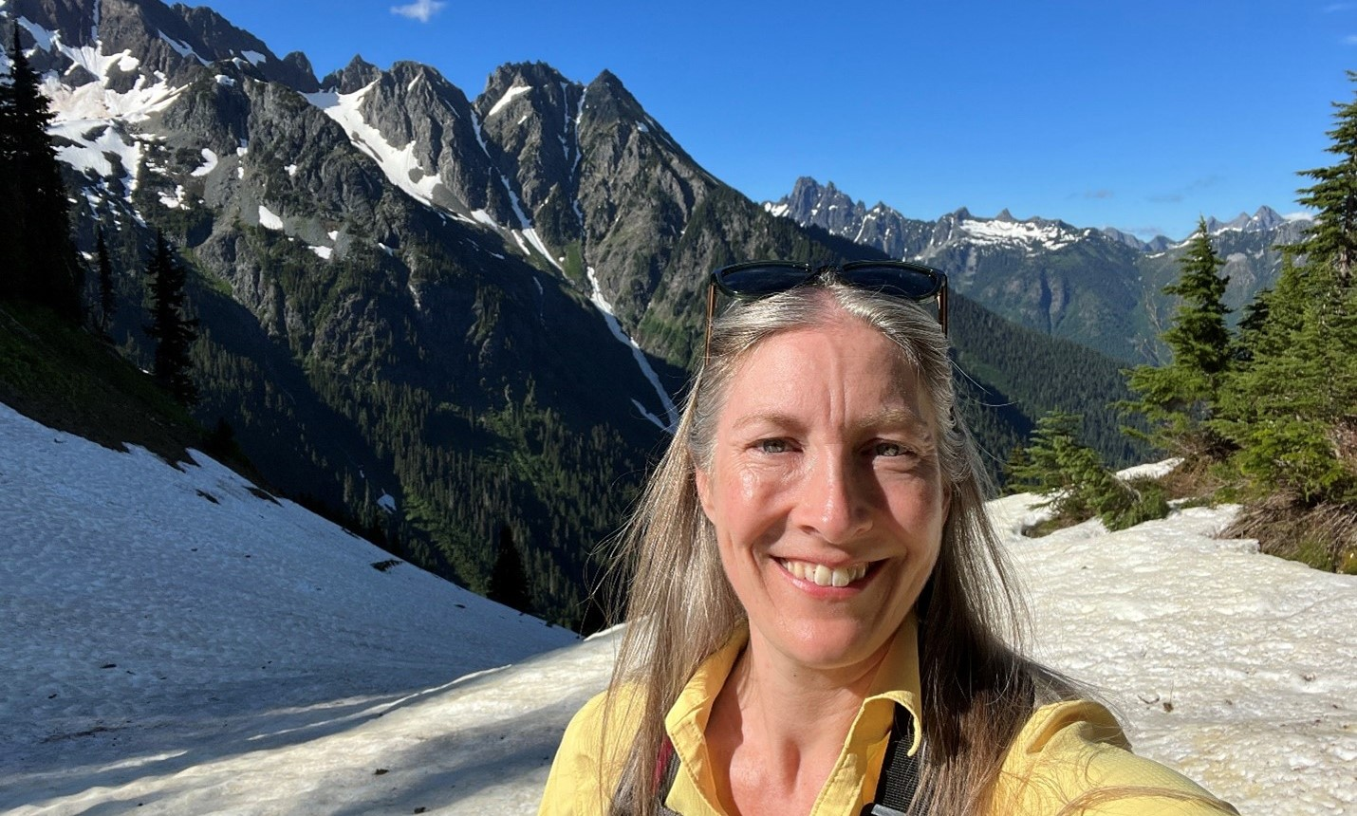

Volunteer Spotlight: Becky Robbins
Meet Becky, a Foothills hike and urban walk leader, Key Instructor, Key Leader, and Super Volunteer who is passionate about helping others get outside to discover the wonders of nature.

Meet Becky

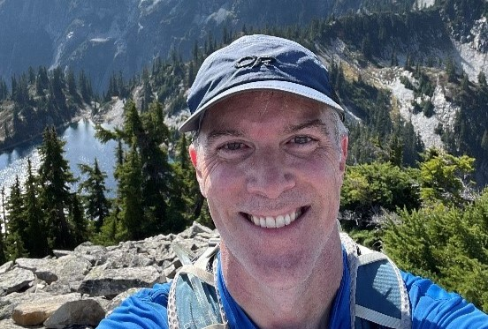

Get to Know Erik Jensen, Foothills Branch Treasurer
Erik joined The Mountaineers in 2022 and has been serving as Foothills Branch Treasurer since 2023. In this role, Erik works with Foothills Committee Chairs and Committee Treasurers as well as Mountaineers staff to manage the overall financials for the branch, approve expenses, and prepare the annual budget. As a branch treasurer, he is also part of the Branch Treasurer Committee and The Mountaineers Finance Committee.

Meet Erik

Volunteer With Us
Staying Found - On Trail Navigation
The 2025 Staying Found - On Trail Navigation course is open for registration. Graduates of Staying Found or Wilderness Navigation are invited to volunteer as course leaders. Responsibilities include attending an online leader orientation, attending a leader practice field trip, and leading an in-person group during a field trip. New leaders will be paired with an experienced leader during the student field trip. If interested, please email Lori Heath by February 28.
There are plenty of opportunities to get involved at the branch level:
- Safety Officer - email Travis Vermeer, Branch Chair.
- At-Large Member - email Travis Vermeer, Branch Chair.
- Events Chair - email Travis Vermeer, Branch Chair. This committee plans and promotes a variety of special events for branch members and non-members. We’re in search of a social butterfly to help plan branch picnics and other social events.
- Strategic Investment Committee Member - email Travis Prescott, Chair.
- Hiking, Backpacking, Urban Walk Committee Treasurer - email Lori Heath, Committee Secretary. The Treasurer supports the committee in coordinating the annual budget process and mid-flight updates, approves expense reimbursements for committee volunteers, and represents the interests of the committee with branch leadership, finance committee, and Mountaineers staff - including development of course pricing guidance.
- Communications Committee Members - email Lori Heath, Chair. This committee publishes the monthly newsletter, maintains the branch website, helps develop branch-related blogs and magazine content, and posts branch news to social media. We’re looking for people who are social media savvy or love to write.

